Irregular Open Curves
# Source: AI Source: Provided by: [Data Path: Persons Table -> ID Column: 1, Name_En Column: Motasem Essam] -> From: [ChatGPT] on [7/25/2026]
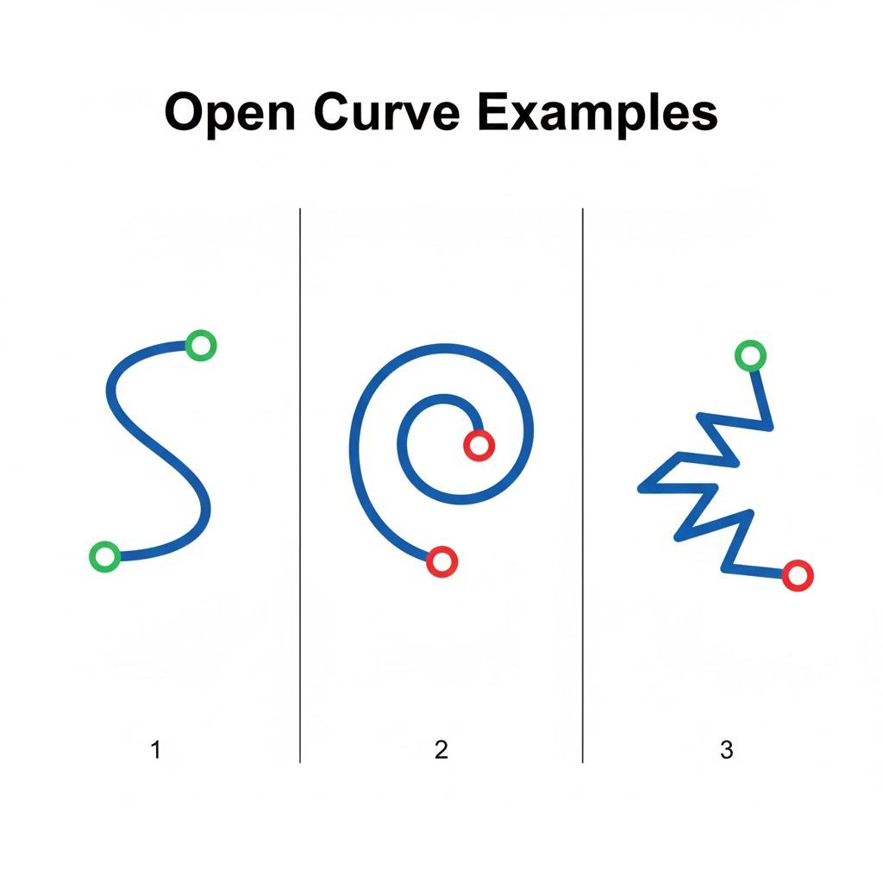
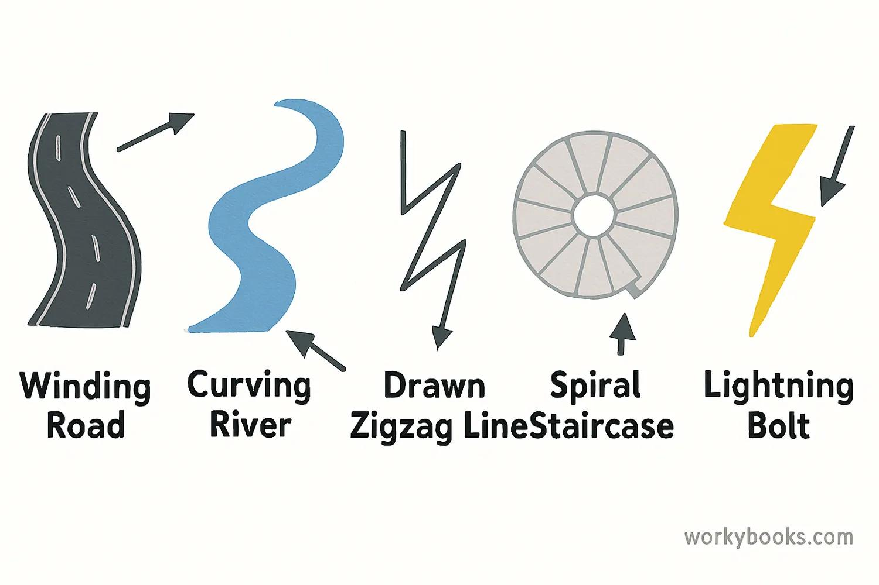
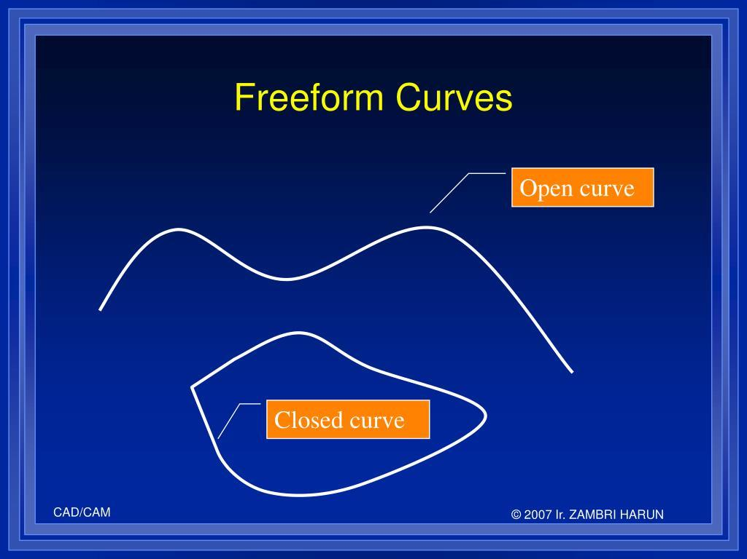
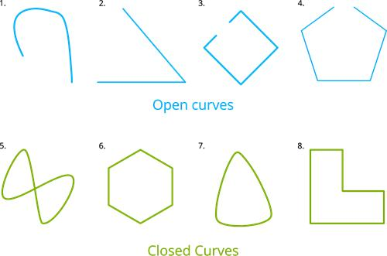
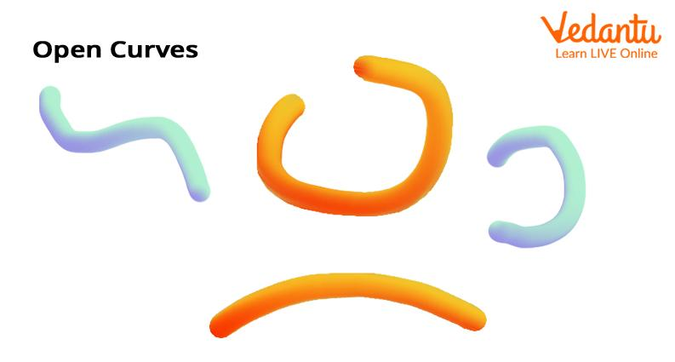

Definition
# Source: AI Source: Provided by: [Data Path: Persons Table -> ID Column: 1, Name_En Column: Motasem Essam] -> From: [ChatGPT] on [7/25/2026]
An Irregular Open Curve is a continuous curved line whose starting point and ending point are different, and whose form does not follow a regular geometric pattern such as a circle or a standard arc.
In simple terms:
An irregular open curve is a non-standard curved line that does not close or enclose a region.
$$\boxed{\text{Irregular Open CurveOpen Curve}+\text{Irregular Form}}$$

Characteristics
# Source: AI Source: Provided by: [Data Path: Persons Table -> ID Column: 1, Name_En Column: Motasem Essam] -> From: [ChatGPT] on [7/25/2026]
An irregular open curve typically:
- Is continuous.
- Has a curved path.
- Has two distinct endpoints.
- Does not return to its starting point.
- Does not enclose a bounded region by itself.
- Has variable curvature.
- Does not require a constant radius.
- Does not require symmetry.
- Usually does not follow a simple standard geometric equation.

Examples

1. Irregular Wavy Open Curve
# Source: AI Source: Provided by: [Data Path: Persons Table -> ID Column: 1, Name_En Column: Motasem Essam] -> From: [ChatGPT] on [7/25/2026]
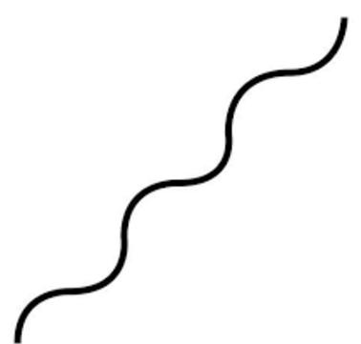
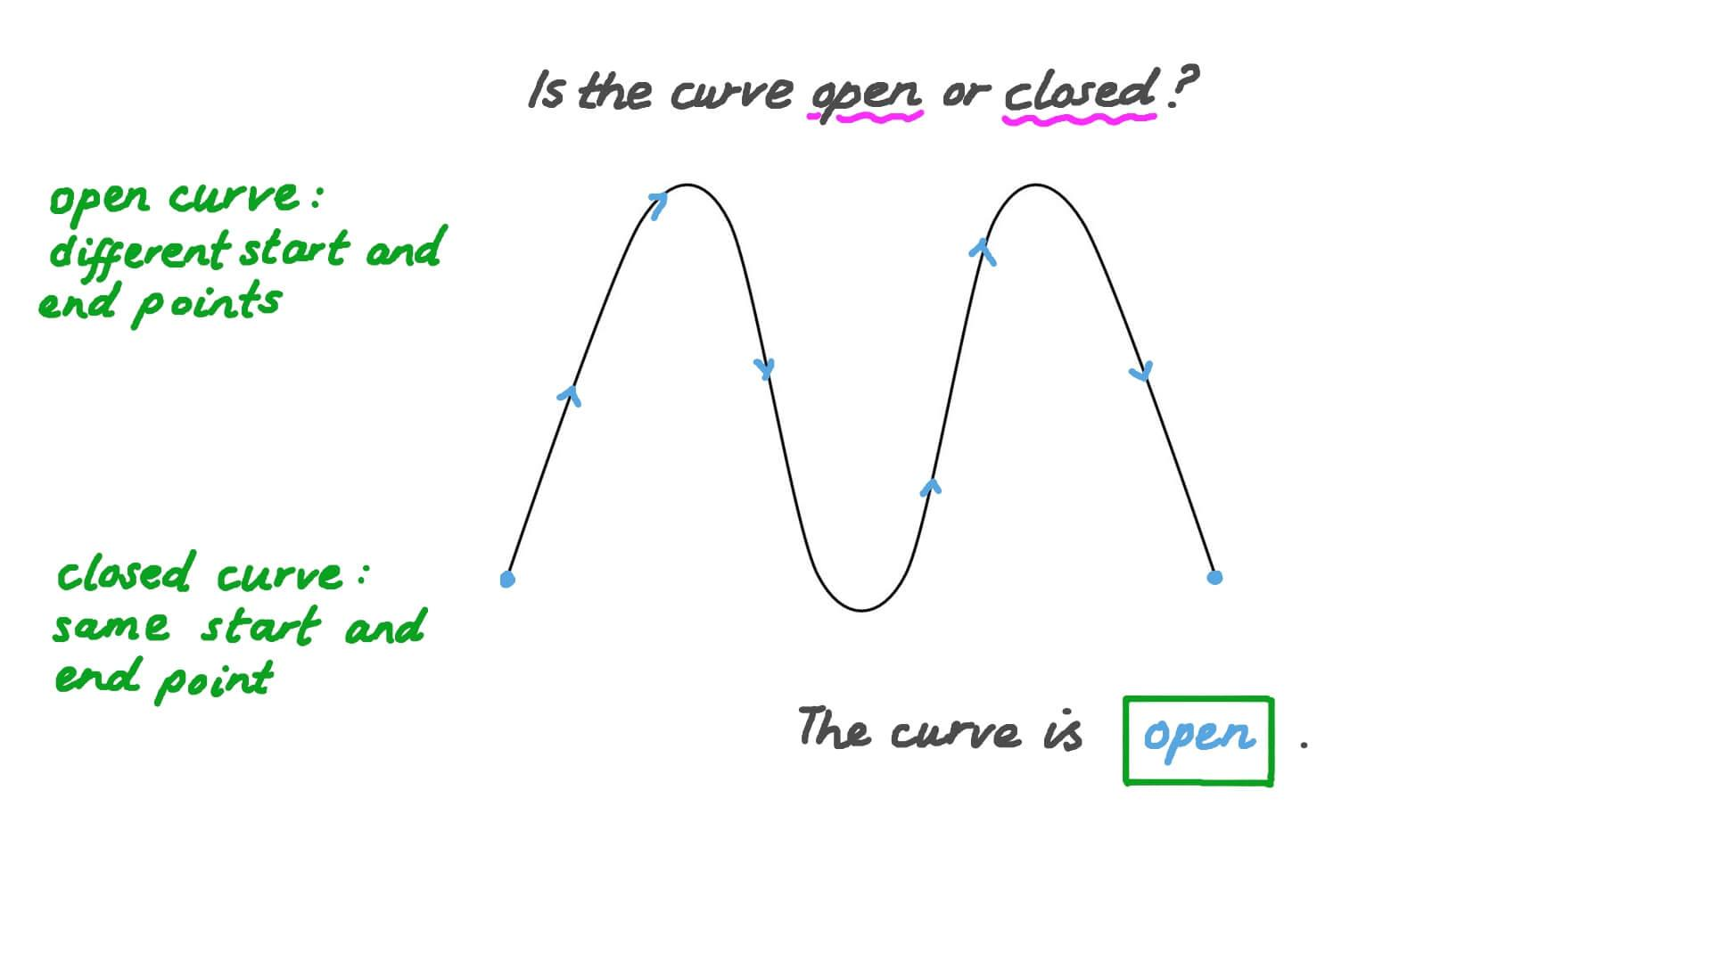
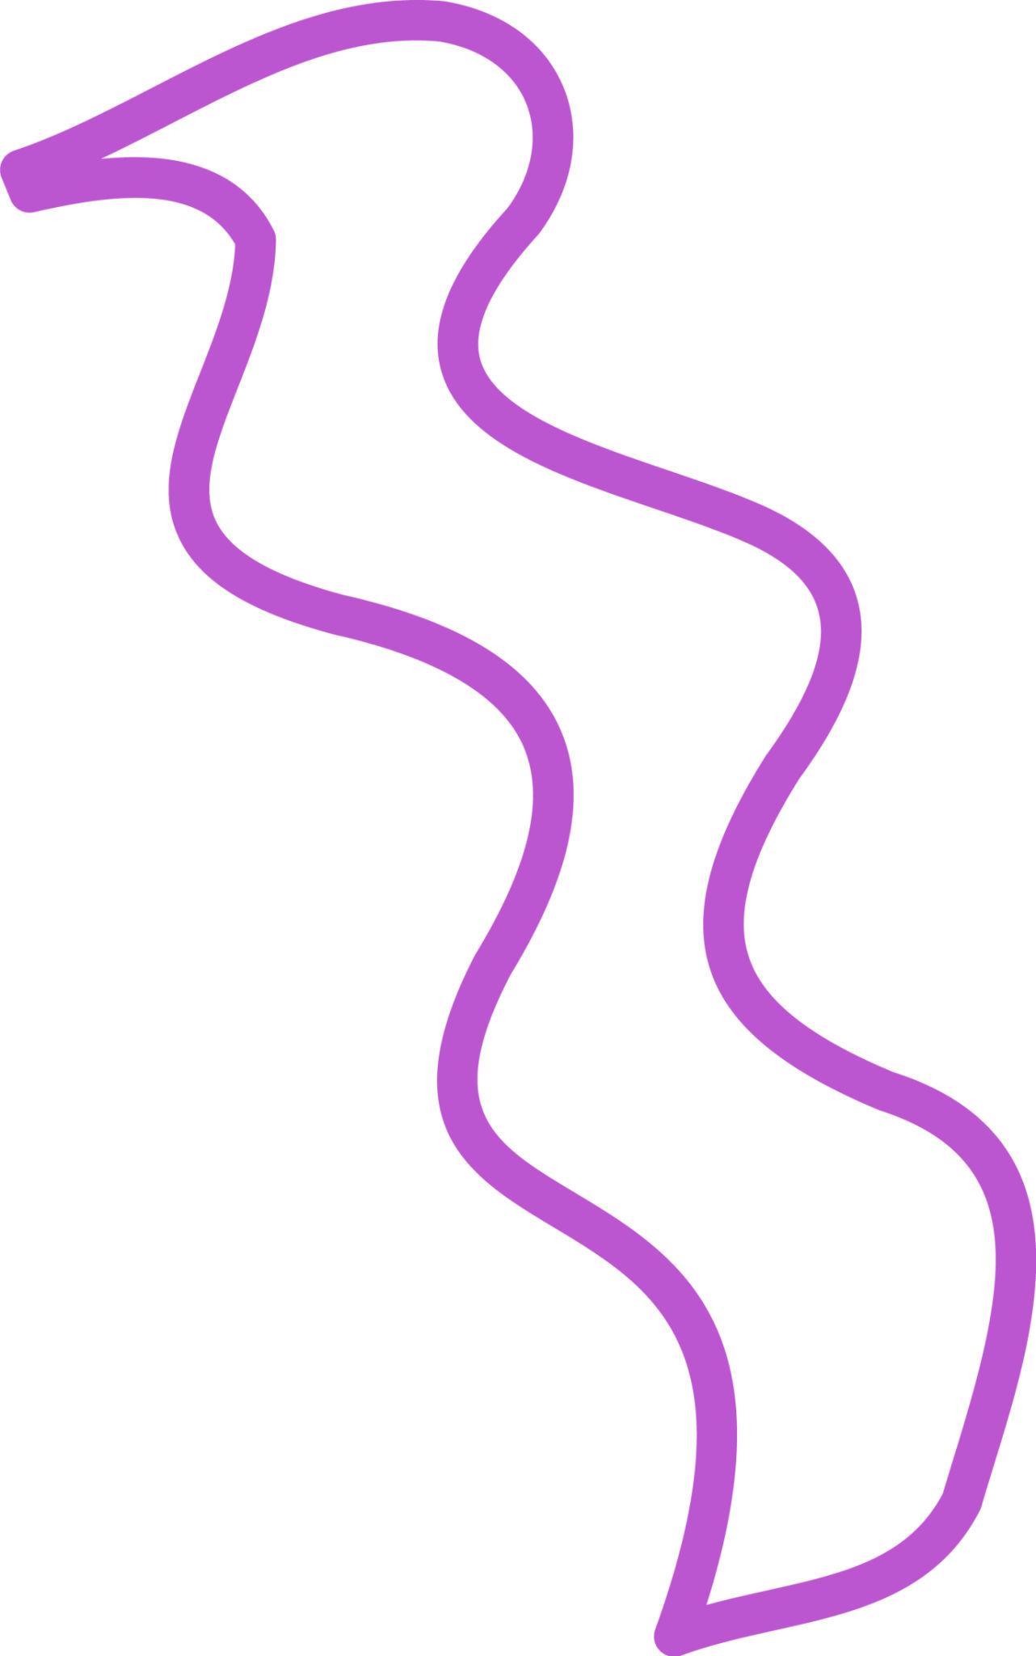
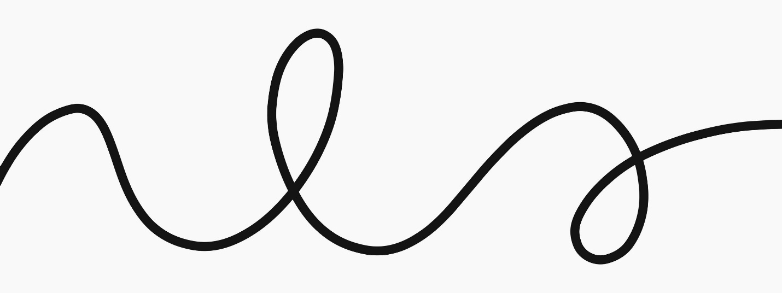
A curved line whose direction and curvature change irregularly while its endpoints remain separate.

2. Irregular Organic Open Curve
# Source: AI Source: Provided by: [Data Path: Persons Table -> ID Column: 1, Name_En Column: Motasem Essam] -> From: [ChatGPT] on [7/25/2026]
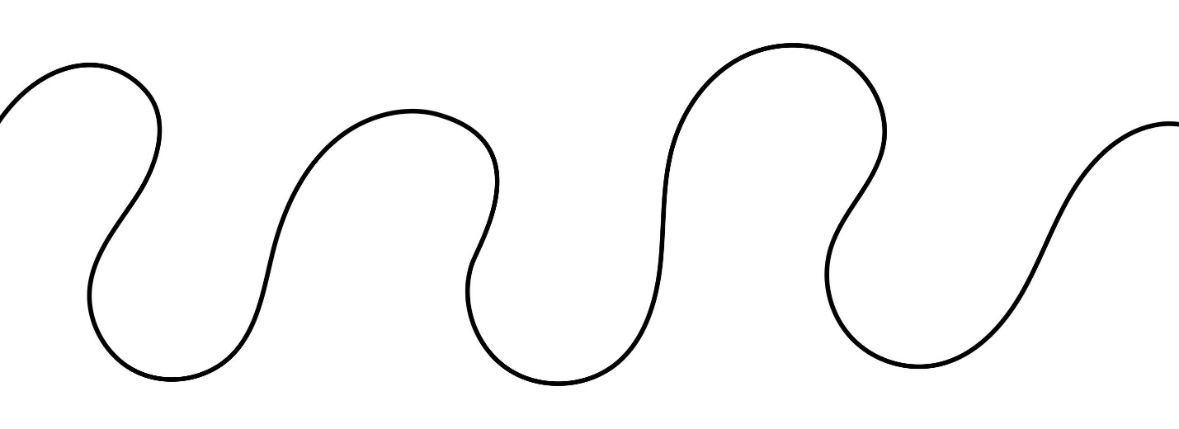
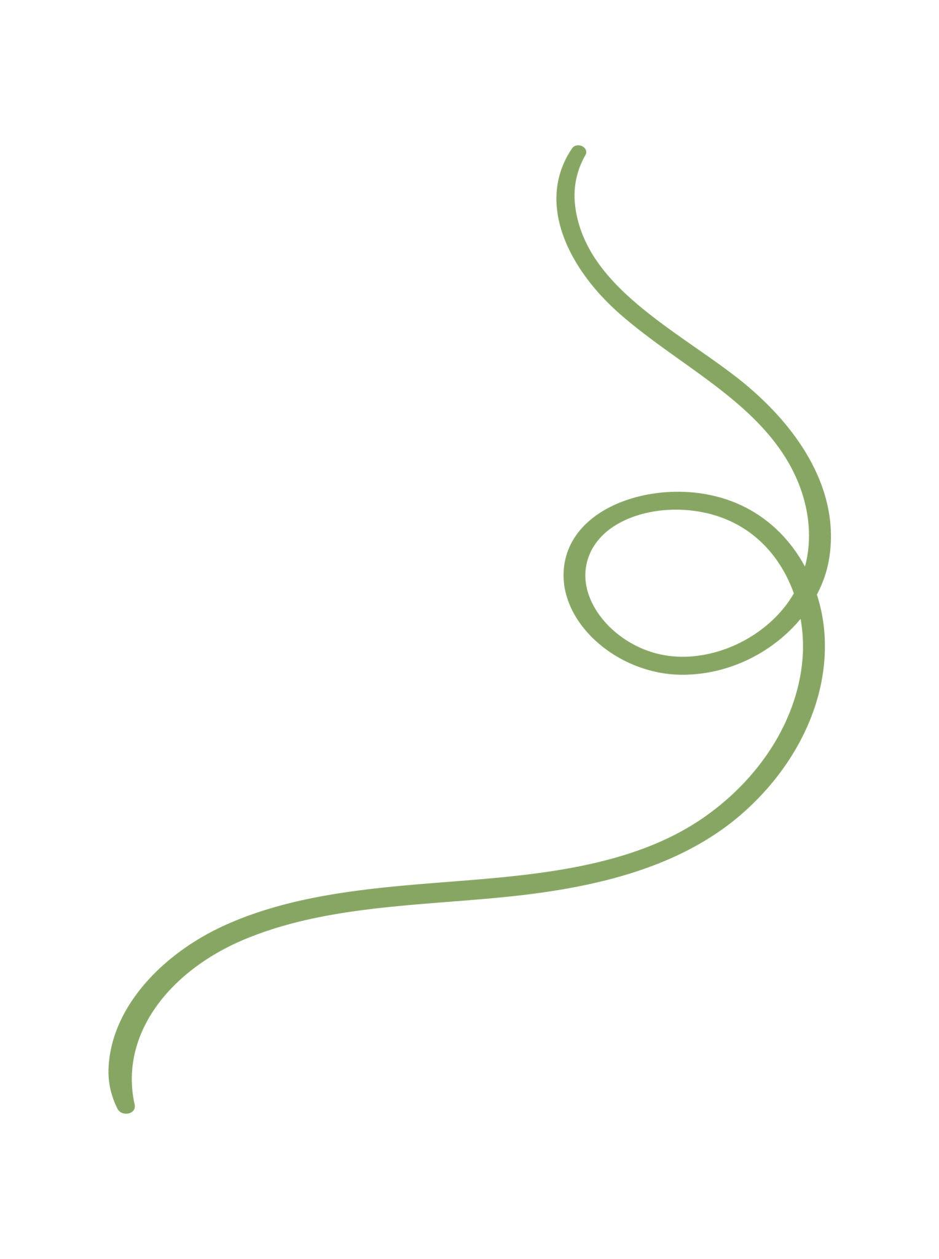
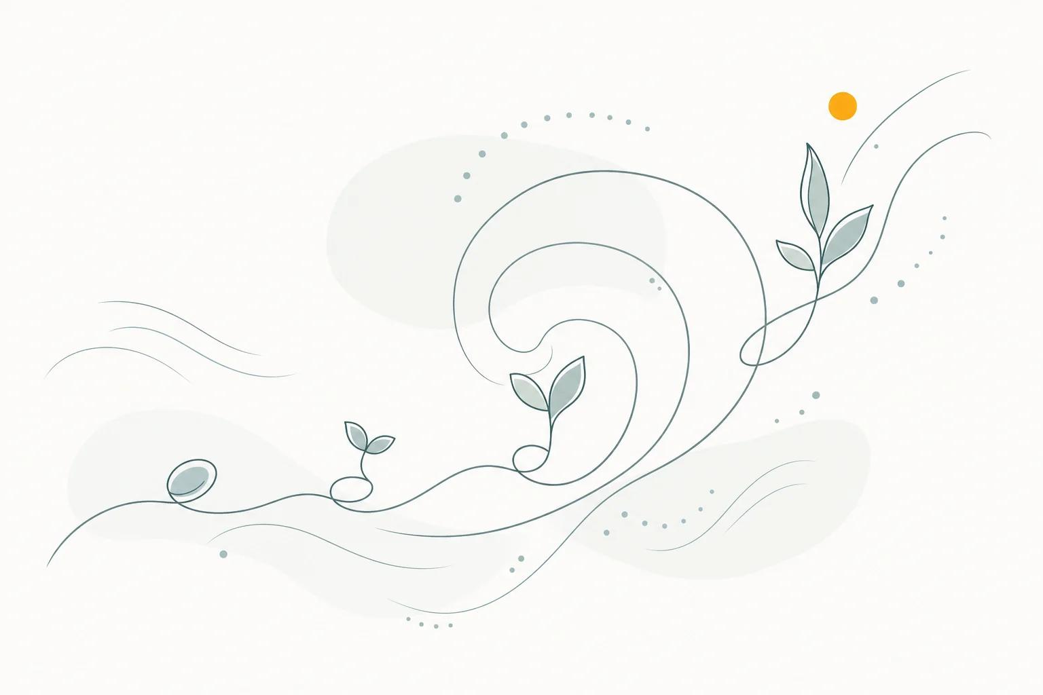
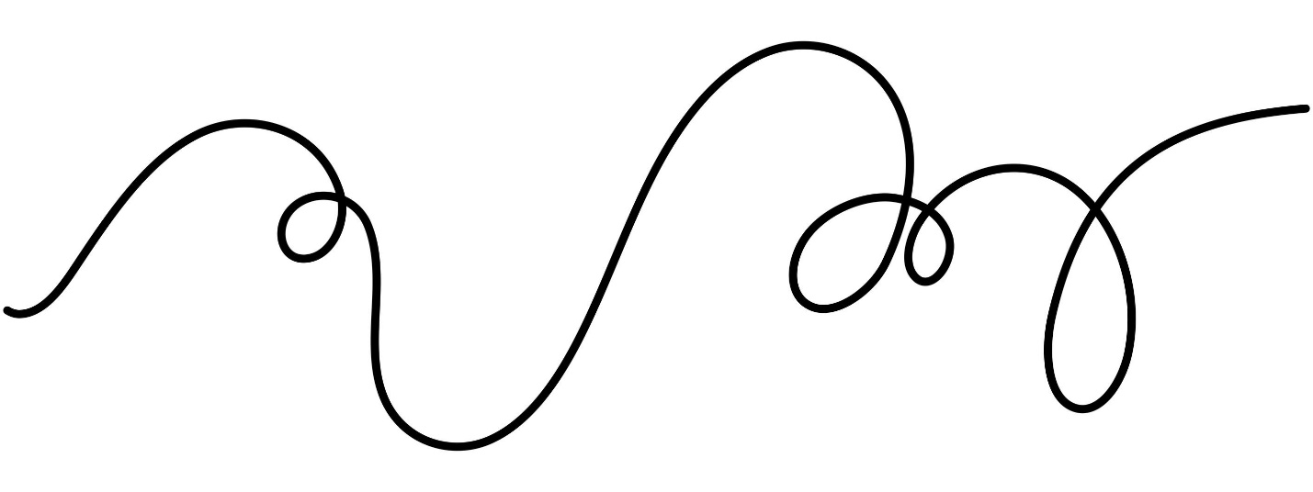
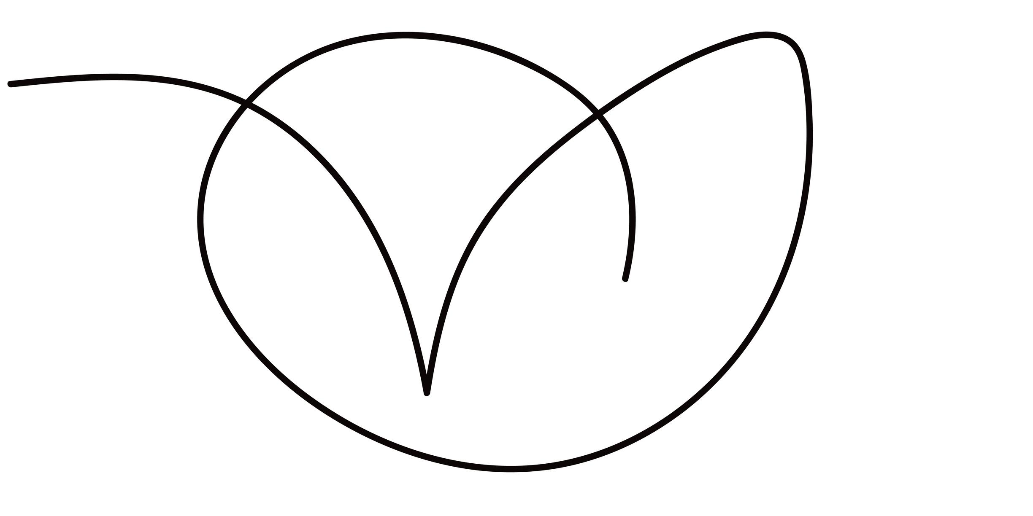
A smooth, flowing open curve resembling forms found in nature.

3. Irregular S-Shaped Open Curve
# Source: AI Source: Provided by: [Data Path: Persons Table -> ID Column: 1, Name_En Column: Motasem Essam] -> From: [ChatGPT] on [7/25/2026]
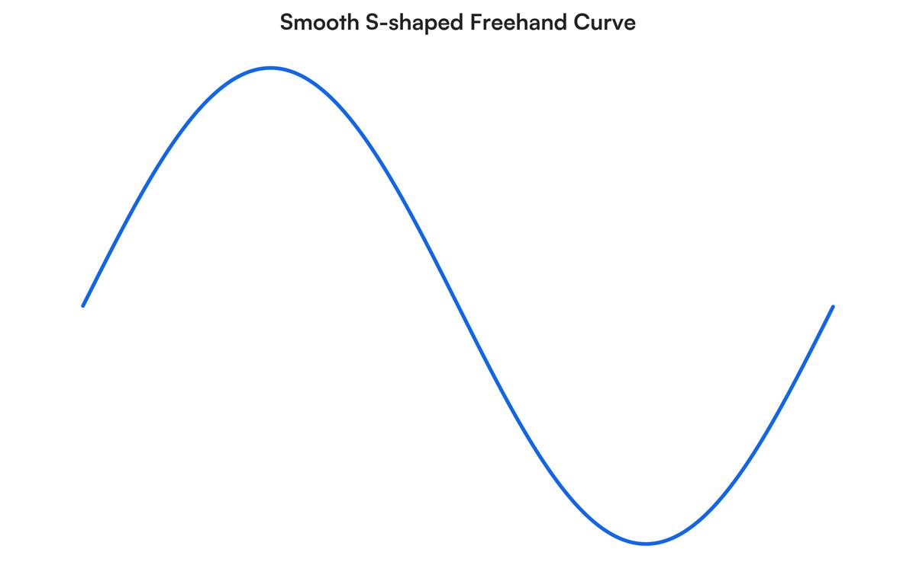
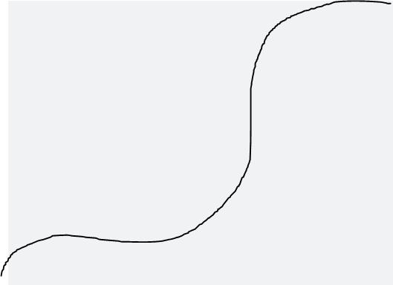
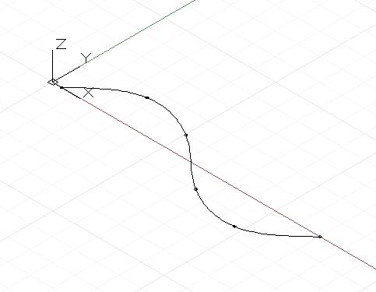
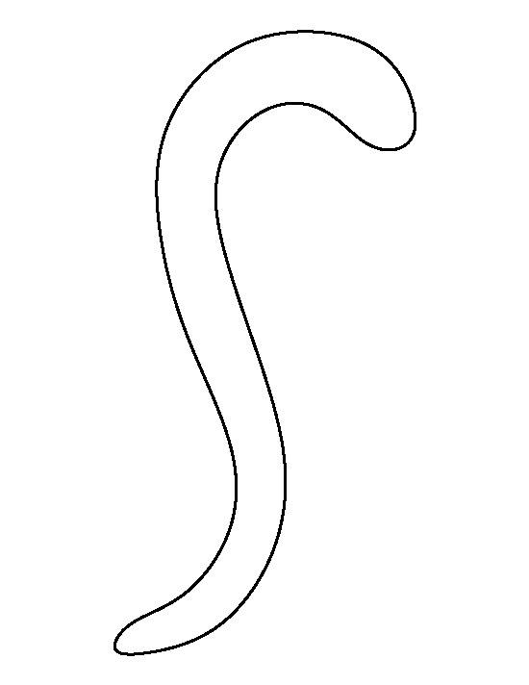
An open curve that changes direction while remaining non-closed.

4. Irregular Spiral-Like Open Curve
# Source: AI Source: Provided by: [Data Path: Persons Table -> ID Column: 1, Name_En Column: Motasem Essam] -> From: [ChatGPT] on [7/25/2026]
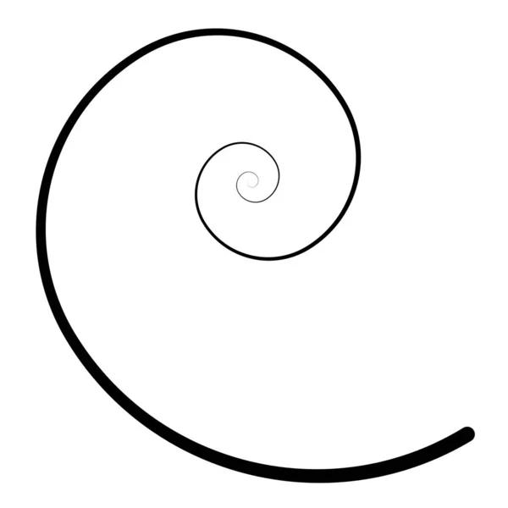
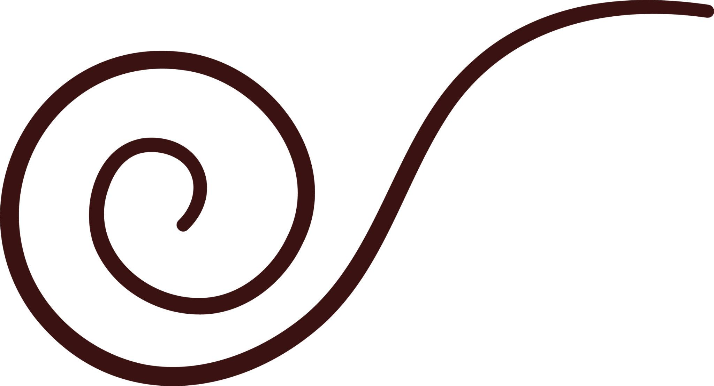
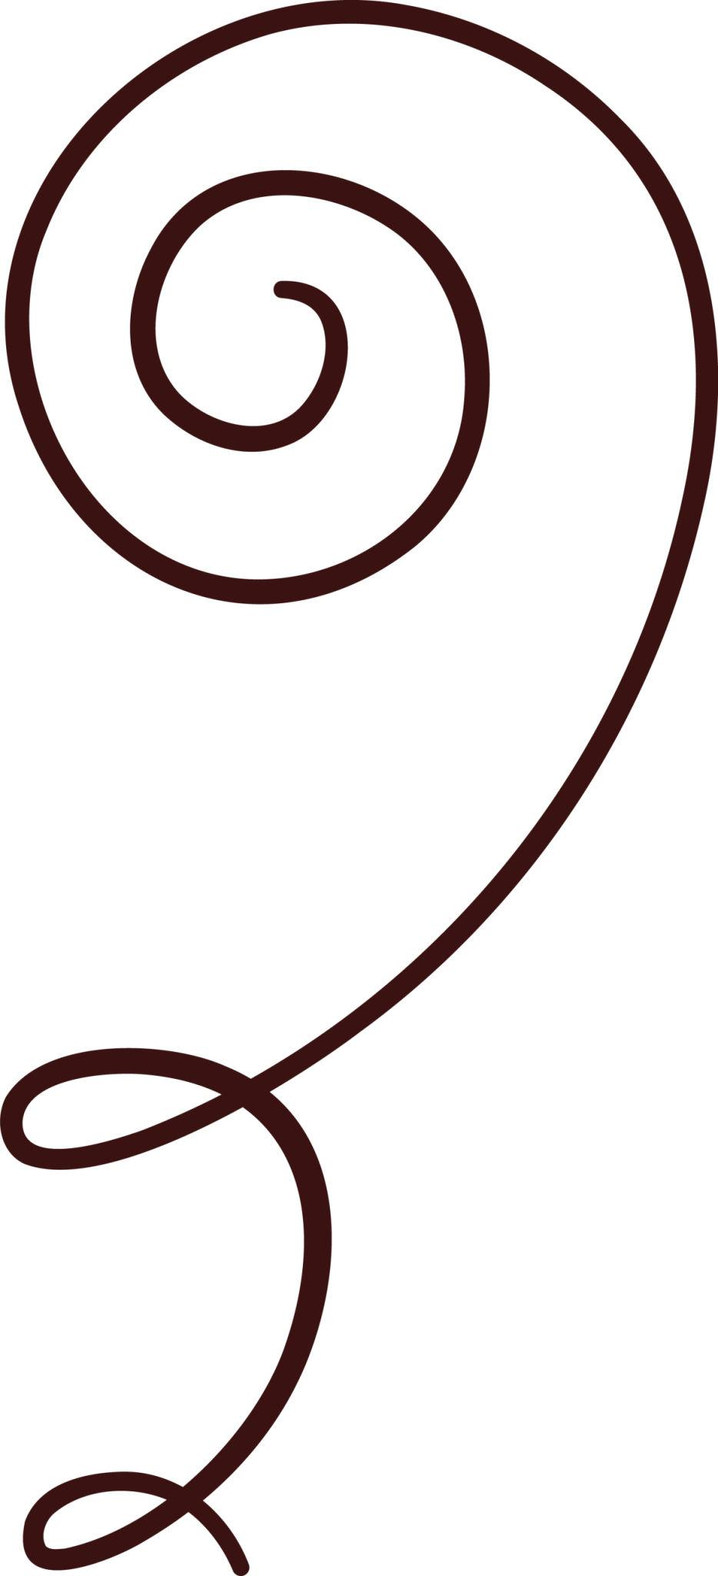
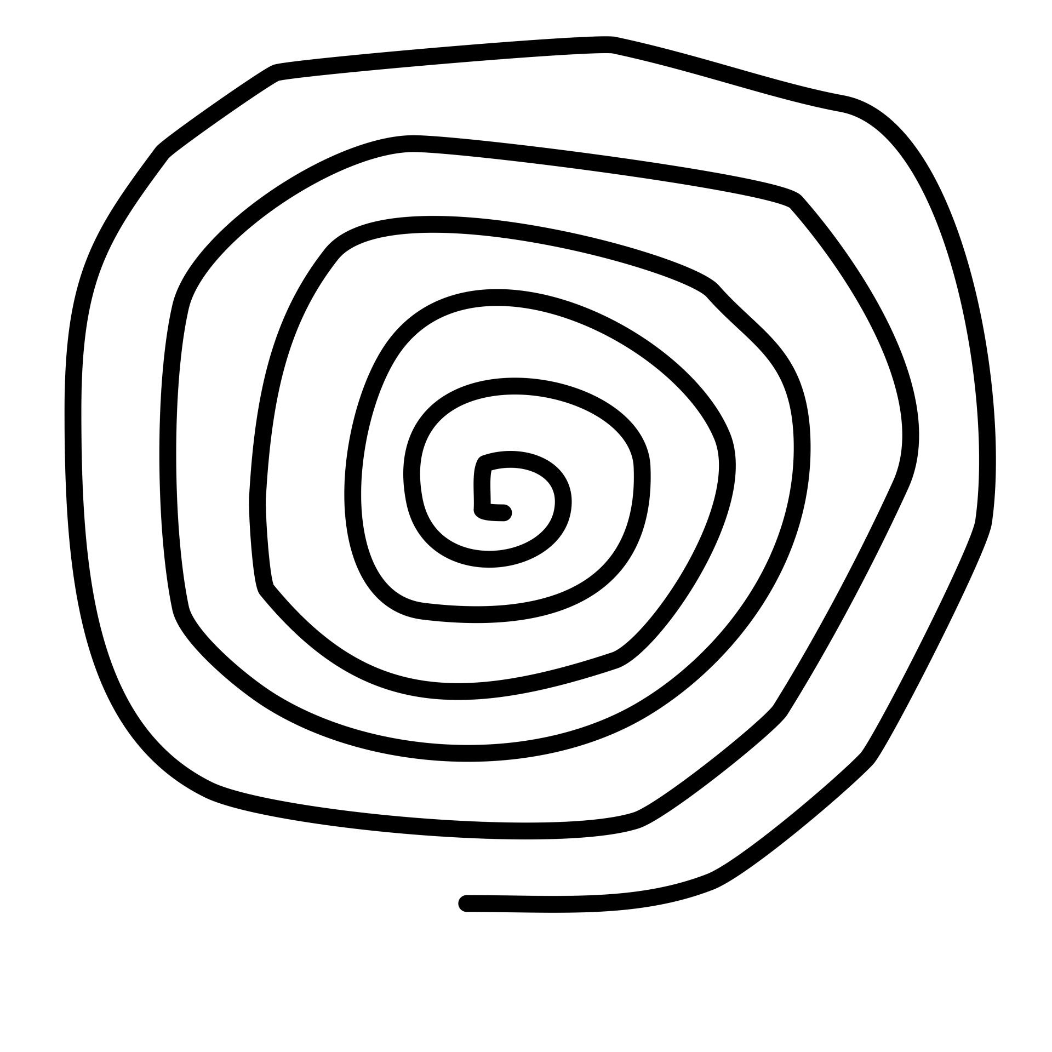
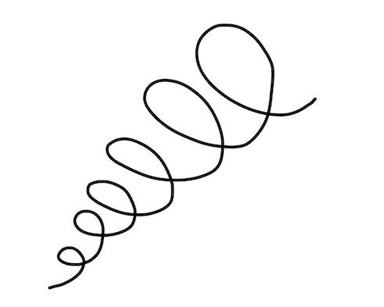
A curve that winds around itself without closing.

Open vs. Closed Curves
# Source: AI Source: Provided by: [Data Path: Persons Table -> ID Column: 1, Name_En Column: Motasem Essam] -> From: [ChatGPT] on [7/25/2026]
Irregular Open Curve
$$P_{\text{start}}≠P_{\text{end}}$$
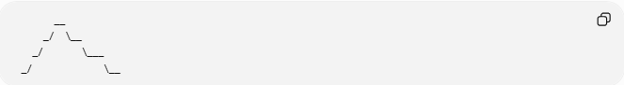
__
_/ \__
_/ \___
_/ \__
The endpoints are different.
Irregular Closed Curve
$$P_{\text{start}}=P_{\text{end}}$$
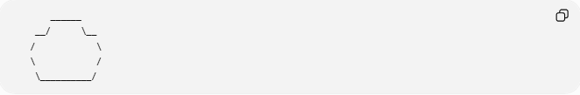
______
__/ \__
/ \
\ /
\__________/
The curve returns to its starting point.

Regular vs. Irregular Open Curves
# Source: AI Source: Provided by: [Data Path: Persons Table -> ID Column: 1, Name_En Column: Motasem Essam] -> From: [ChatGPT] on [7/25/2026]
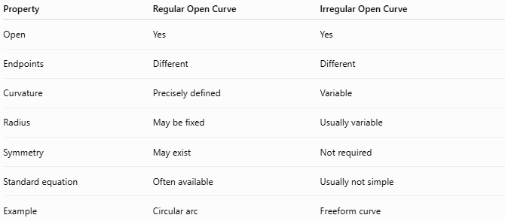
Property | Regular Open Curve | Irregular Open Curve
Open | Yes | Yes
Endpoints | Different | Different
Curvature | Precisely defined | Variable
Radius | May be fixed | Usually variable
Symmetry | May exist | Not required
Standard equation | Often available | Usually not simple
Example | Circular arc | Freeform curve
For example, a circular arc is a regular open curve because it has a constant radius:
$$r=\text{constant}$$
An irregular open curve generally has changing curvature.

Mathematical Representation
# Source: AI Source: Provided by: [Data Path: Persons Table -> ID Column: 1, Name_En Column: Motasem Essam] -> From: [ChatGPT] on [7/25/2026]
An irregular open curve can be represented parametrically:
$$x=x\left(t\right), y=y\left(t\right)$$
for:
$$a≤t≤b$$
with:
$$\boxed{\left(x\left(a\right),y\left(a\right)\right)≠\left(x\left(b\right),y\left(b\right)\right)}$$
This distinguishes it from a closed parametric curve.

Arc Length
# Source: AI Source: Provided by: [Data Path: Persons Table -> ID Column: 1, Name_En Column: Motasem Essam] -> From: [ChatGPT] on [7/25/2026]
Although an irregular open curve does not enclose an area by itself, its length can be measured.
For a parametric curve:
$$x=x\left(t\right), y=y\left(t\right)$$
the arc length is:
$$\boxed{L=\int_{a}^{b}{\sqrt{{\left(\frac{dx}{dt}\right)}^{2}+{\left(\frac{dy}{dt}\right)}^{2}}},dt}$$

Area
# Source: AI Source: Provided by: [Data Path: Persons Table -> ID Column: 1, Name_En Column: Motasem Essam] -> From: [ChatGPT] on [7/25/2026]
An individual open curve does not enclose a region, so it does not have an enclosed area by itself.
However, if an open curve is combined with other boundaries to create a closed region, the resulting region can have an area.
For example:
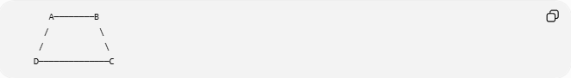
A────────B
/ \
/ \
D──────────────C
The curved boundary together with straight segments creates a closed region.

Types of Irregular Open Curves
# Source: AI Source: Provided by: [Data Path: Persons Table -> ID Column: 1, Name_En Column: Motasem Essam] -> From: [ChatGPT] on [7/25/2026]
Within your classification system, you can distinguish:

1. Organic Irregular Open Curves
# Source: AI Source: Provided by: [Data Path: Persons Table -> ID Column: 1, Name_En Column: Motasem Essam] -> From: [ChatGPT] on [7/25/2026]
Smooth, natural-looking open curves.
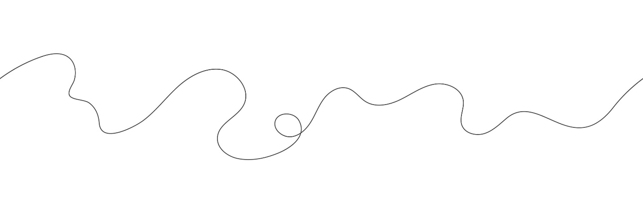
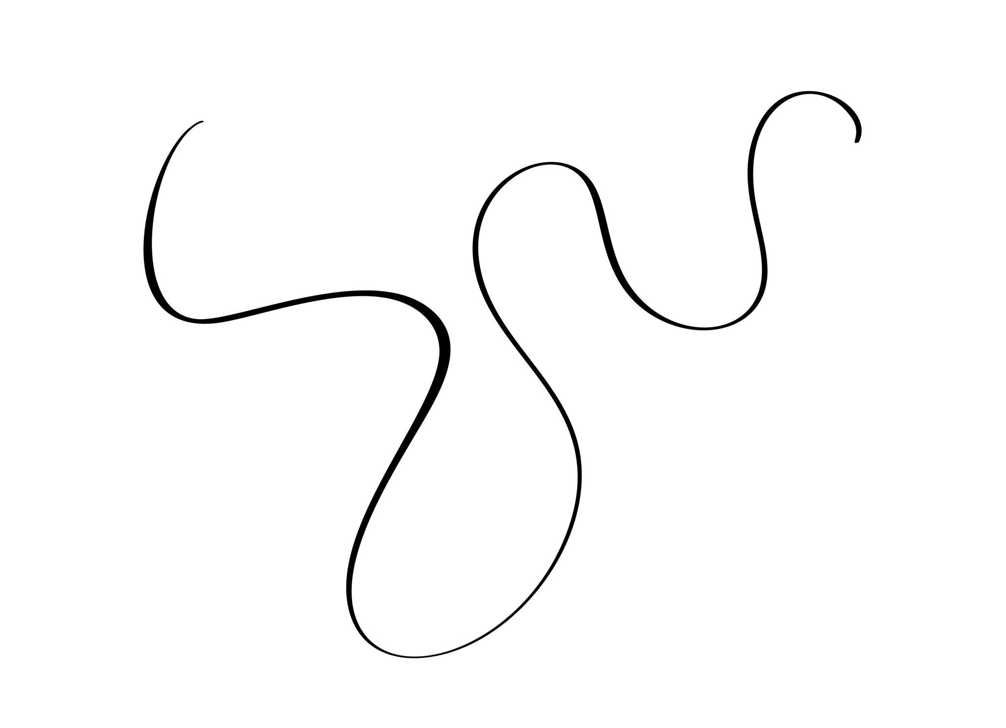
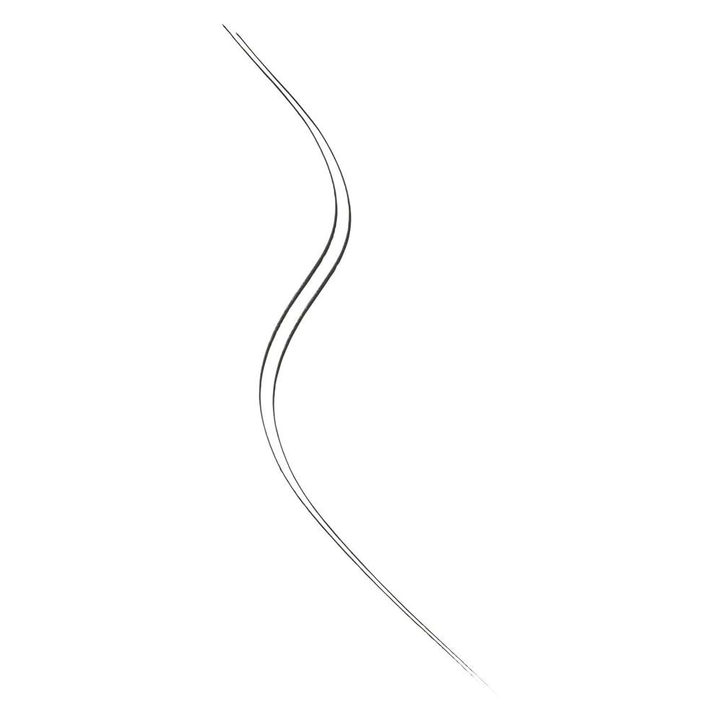
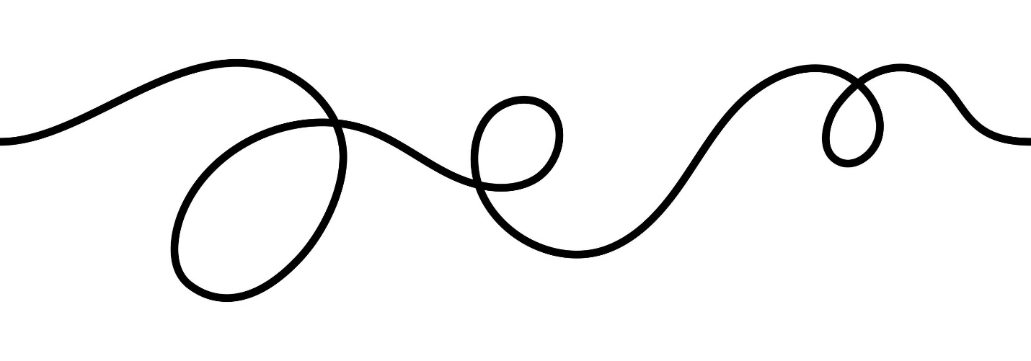
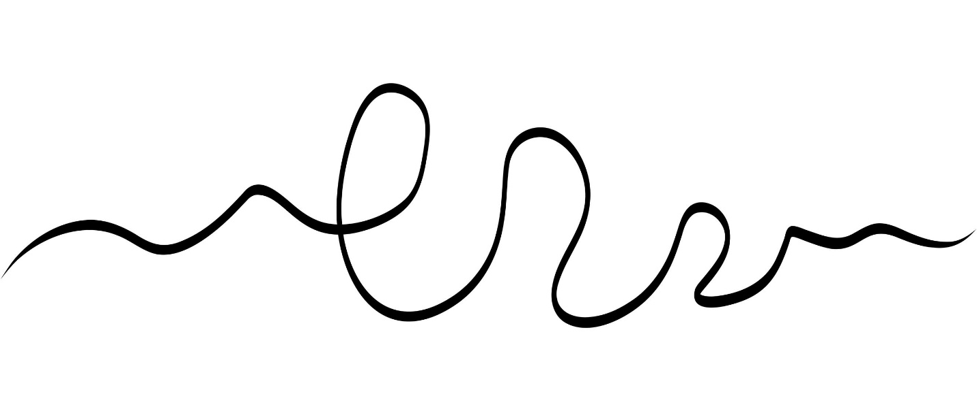

2. Freeform Irregular Open Curves
# Source: AI Source: Provided by: [Data Path: Persons Table -> ID Column: 1, Name_En Column: Motasem Essam] -> From: [ChatGPT] on [7/25/2026]
Artificially designed curves with freely controlled curvature.
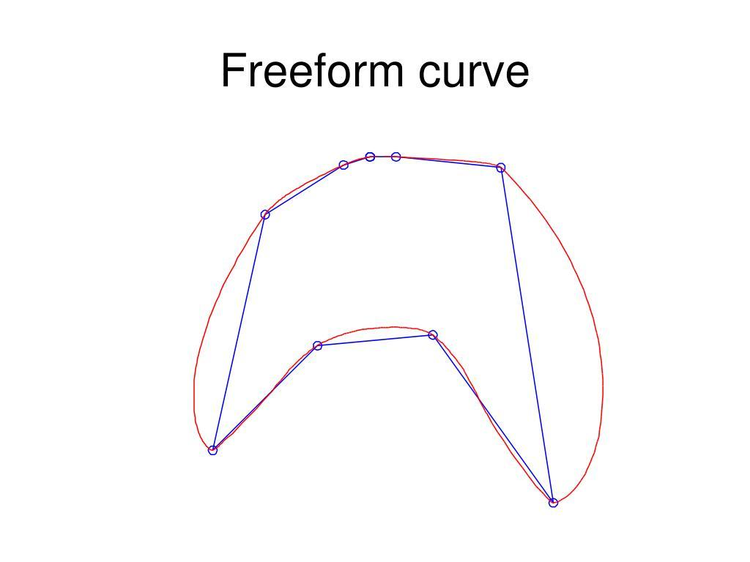
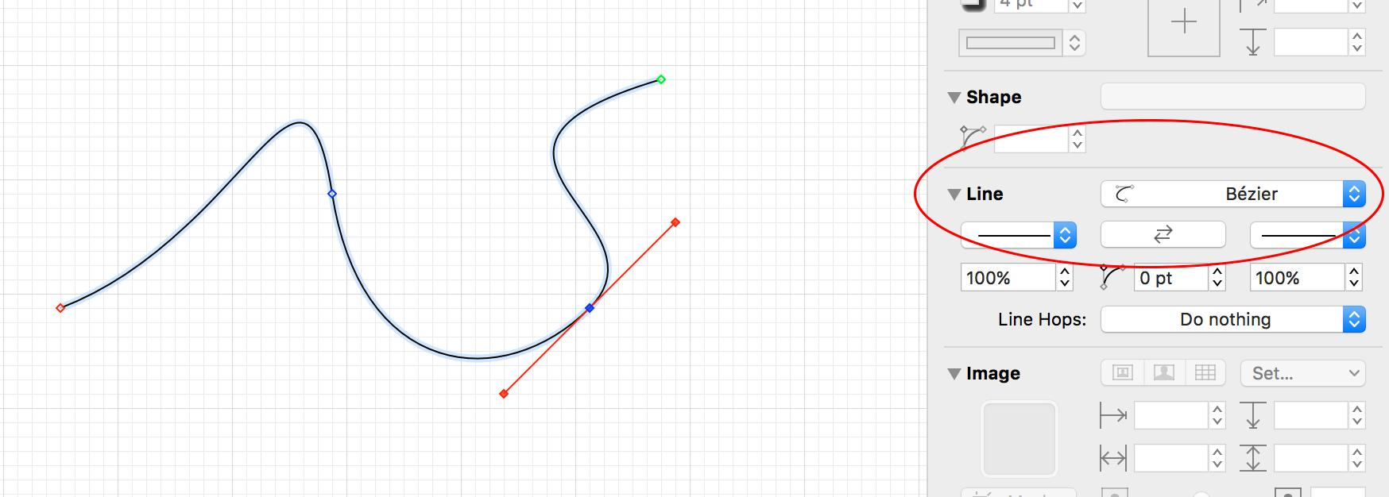
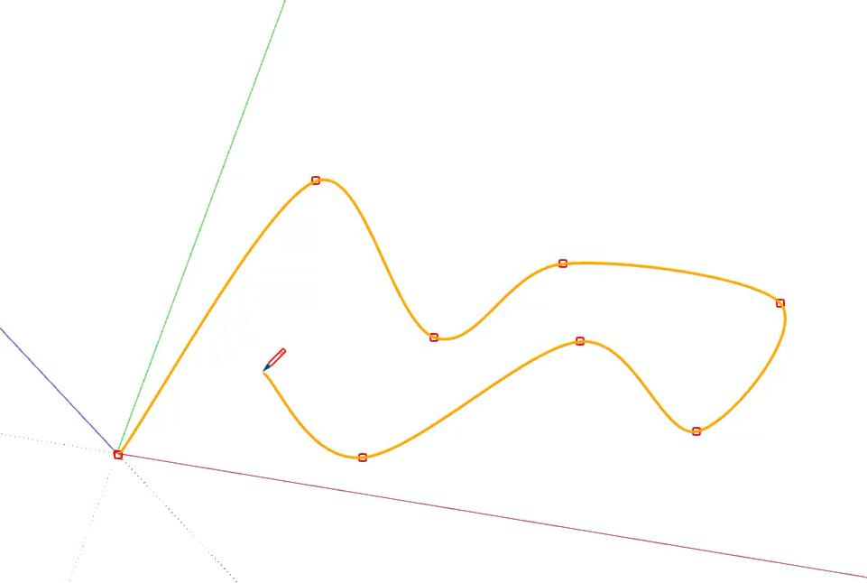
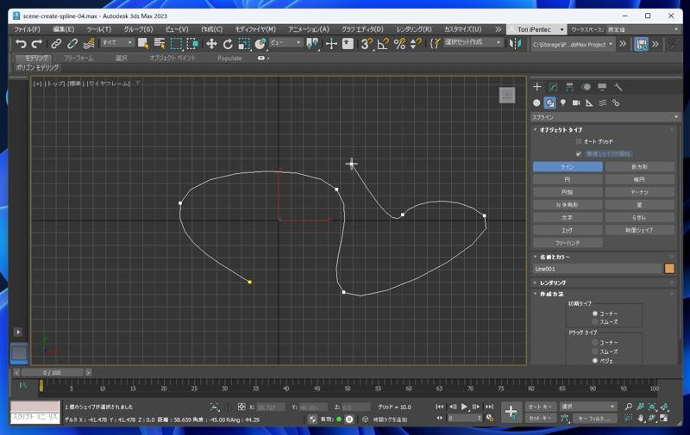
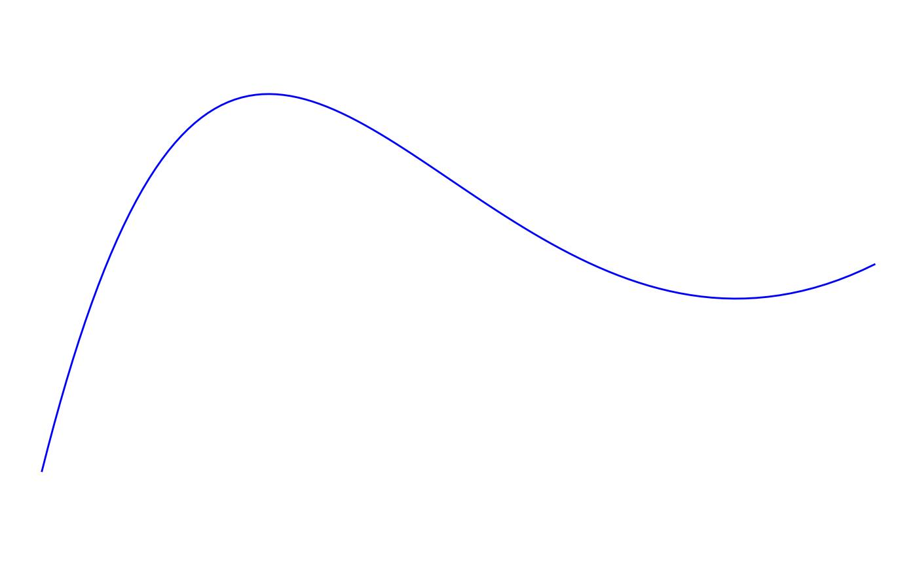
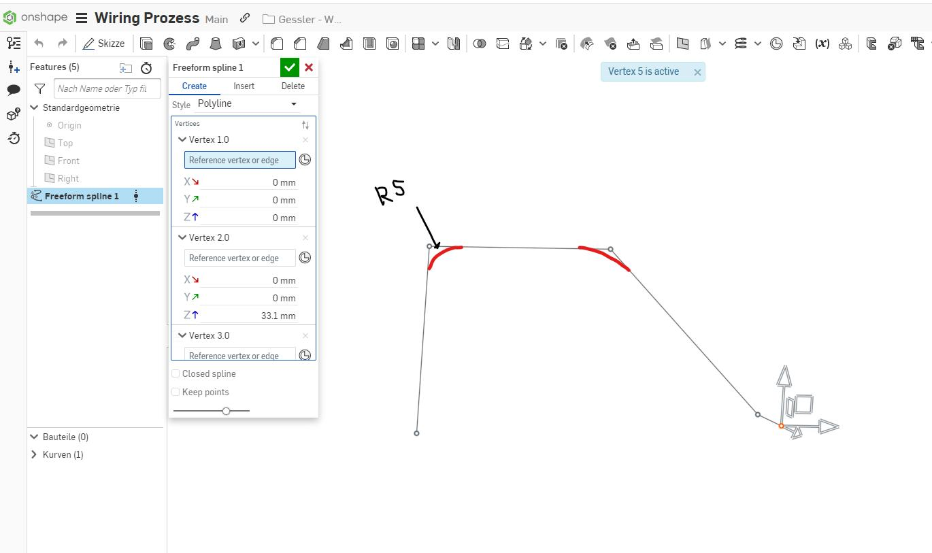

3. Natural Irregular Open Curves
# Source: AI Source: Provided by: [Data Path: Persons Table -> ID Column: 1, Name_En Column: Motasem Essam] -> From: [ChatGPT] on [7/25/2026]
Irregular curved paths occurring naturally, such as portions of coastlines or branches.
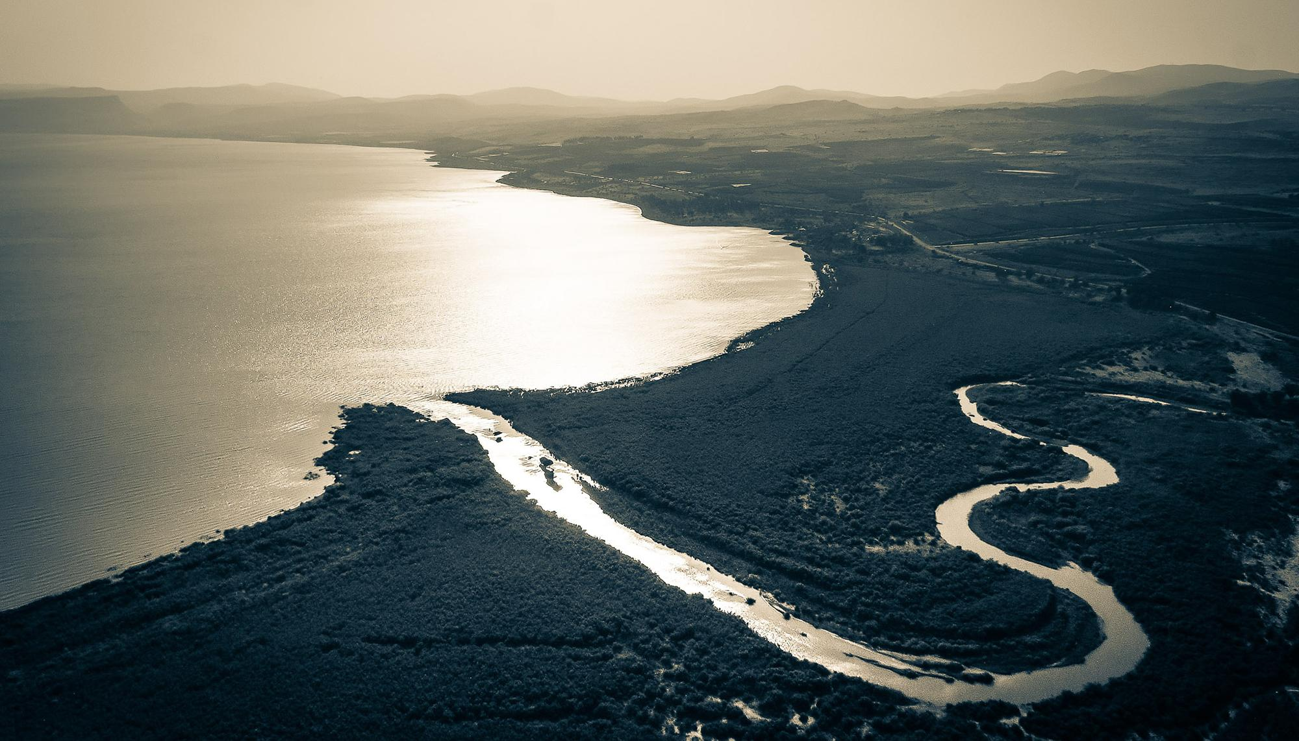
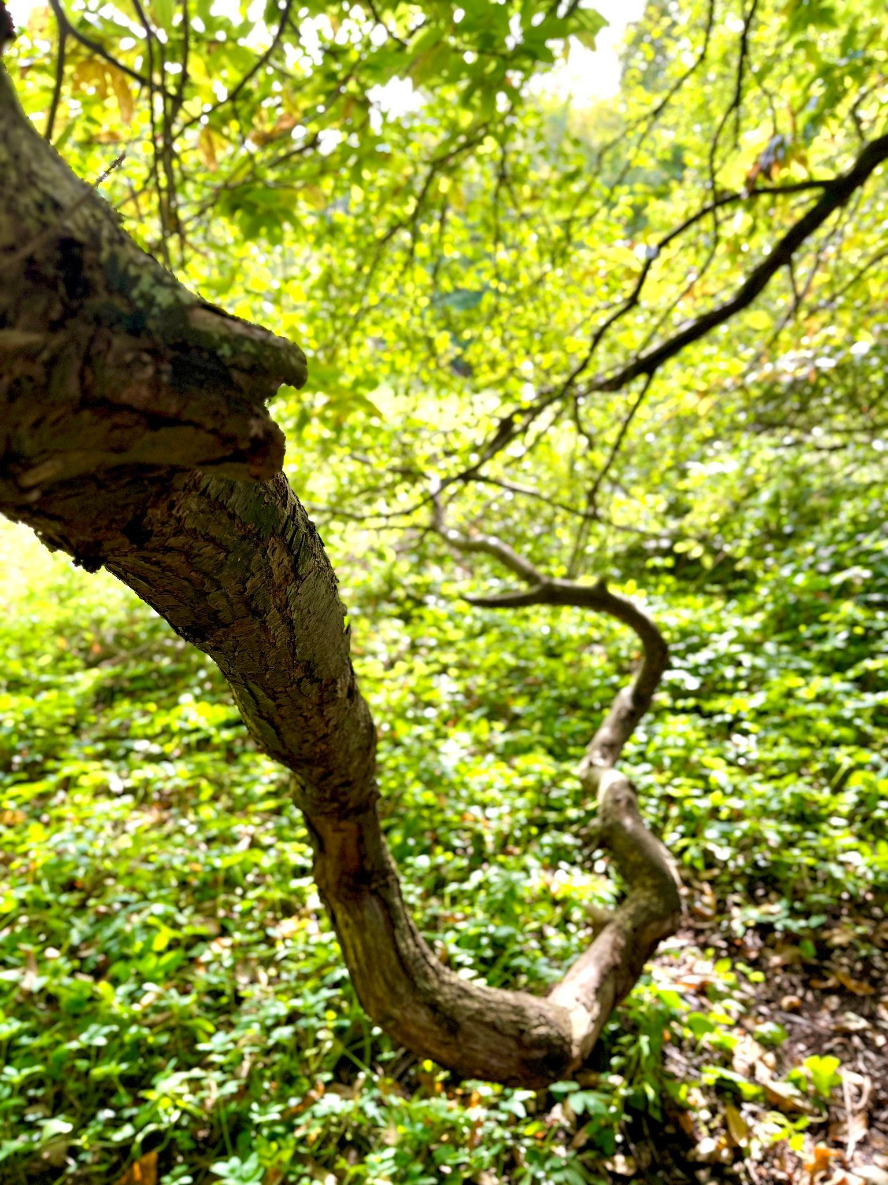
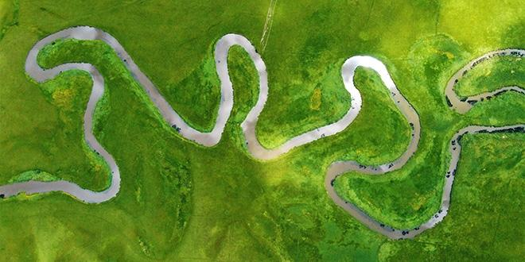
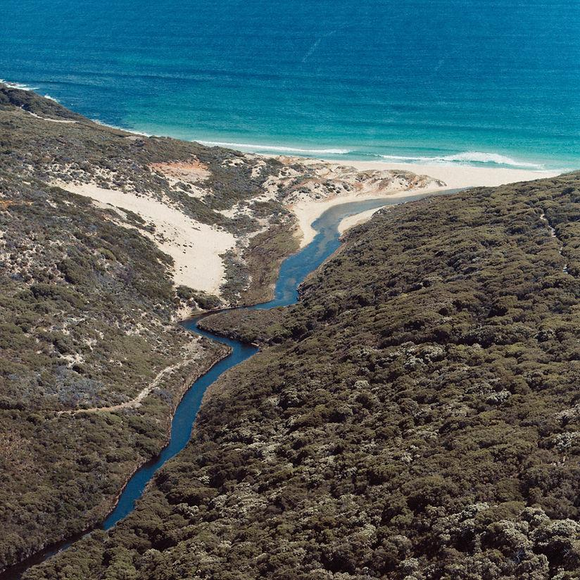
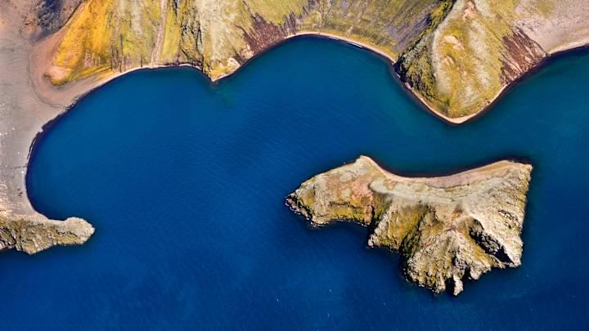
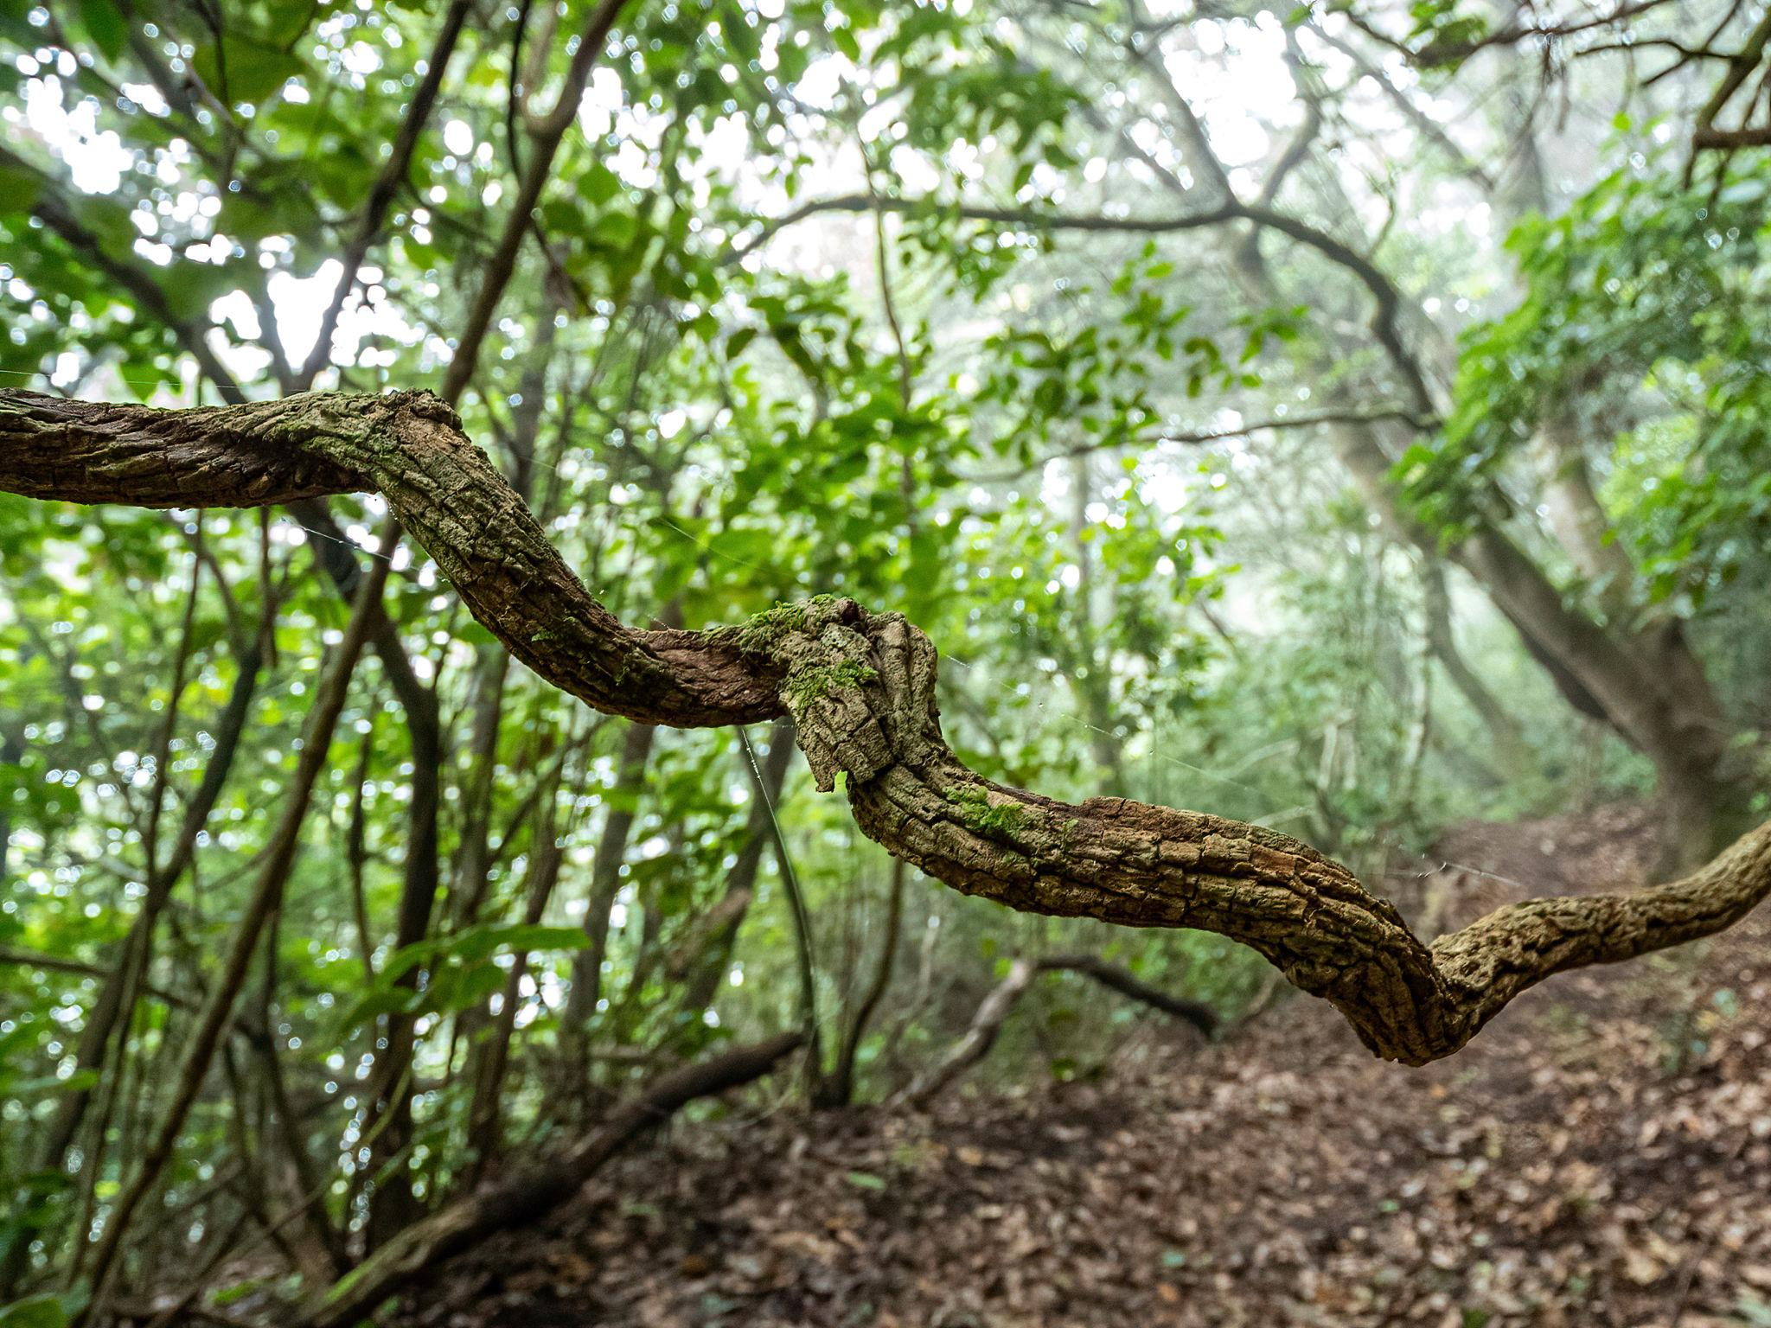
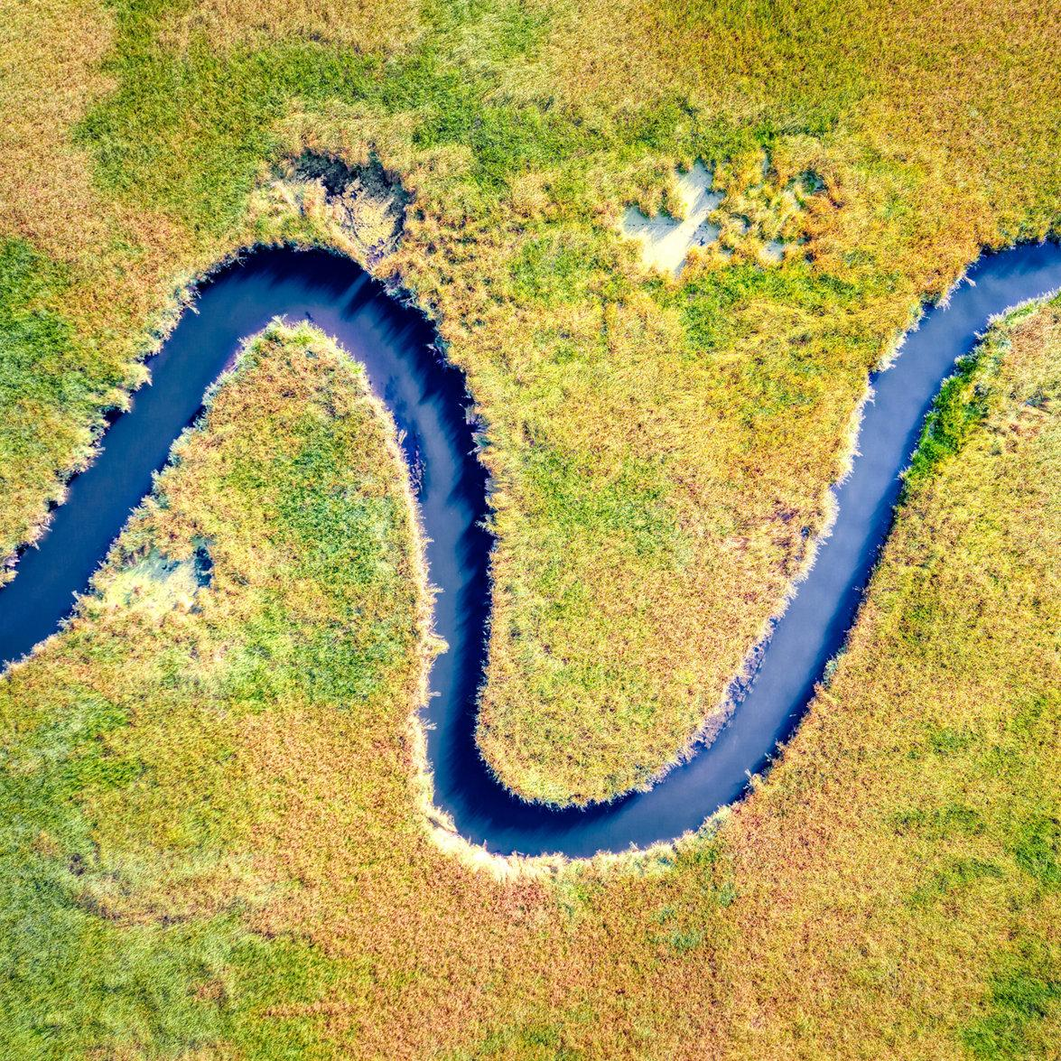

4. Wavy Irregular Open Curves
# Source: AI Source: Provided by: [Data Path: Persons Table -> ID Column: 1, Name_En Column: Motasem Essam] -> From: [ChatGPT] on [7/25/2026]
Curves with irregular waves or undulations.
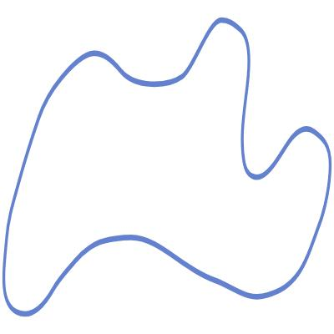
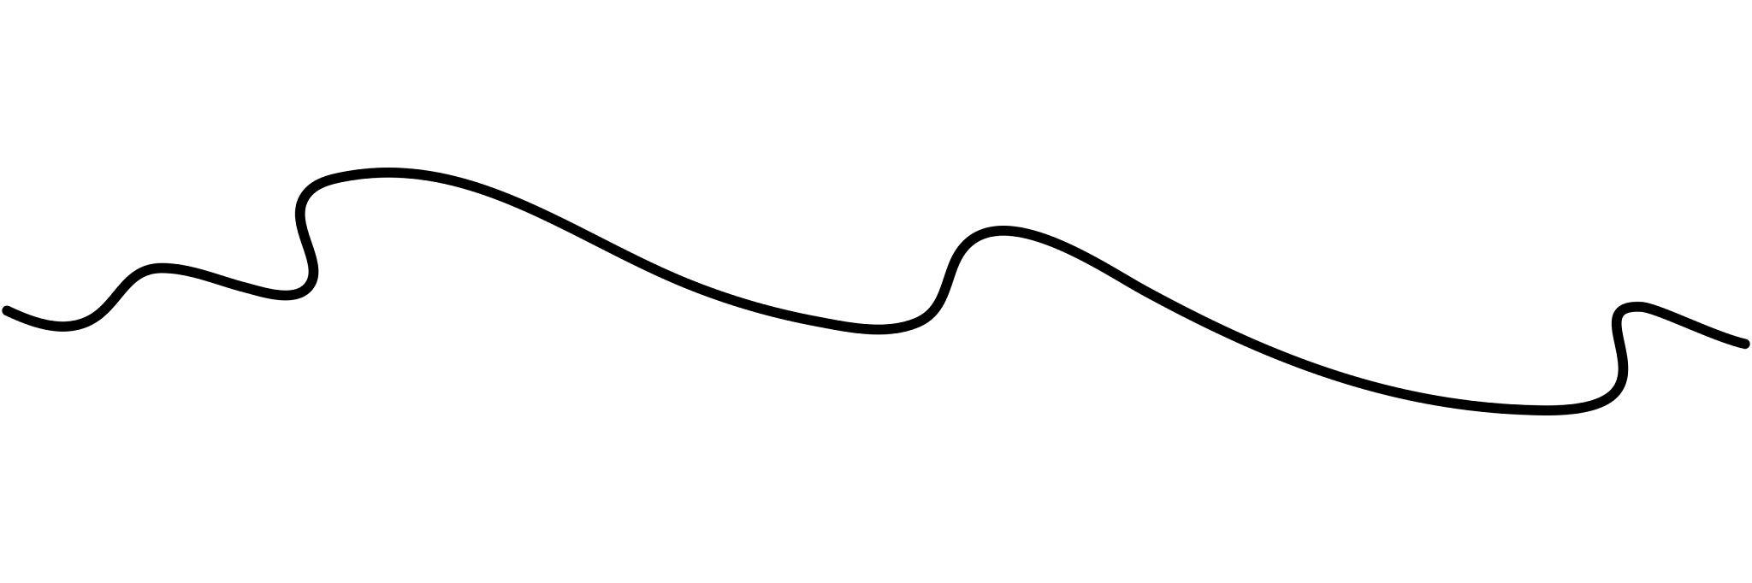
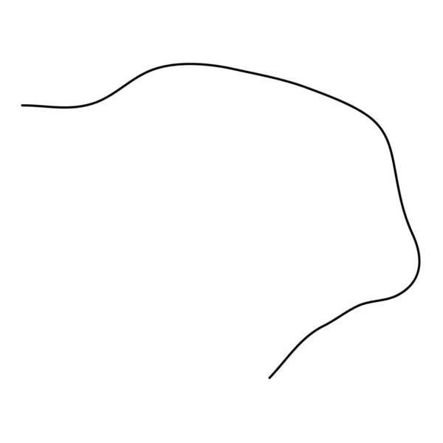

5. Spiral-Like Irregular Open Curves
# Source: AI Source: Provided by: [Data Path: Persons Table -> ID Column: 1, Name_En Column: Motasem Essam] -> From: [ChatGPT] on [7/25/2026]
Curves that wind around without returning to their starting point.
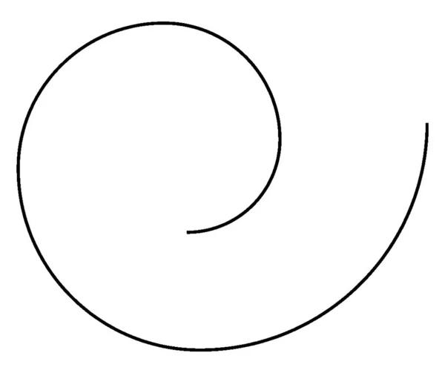
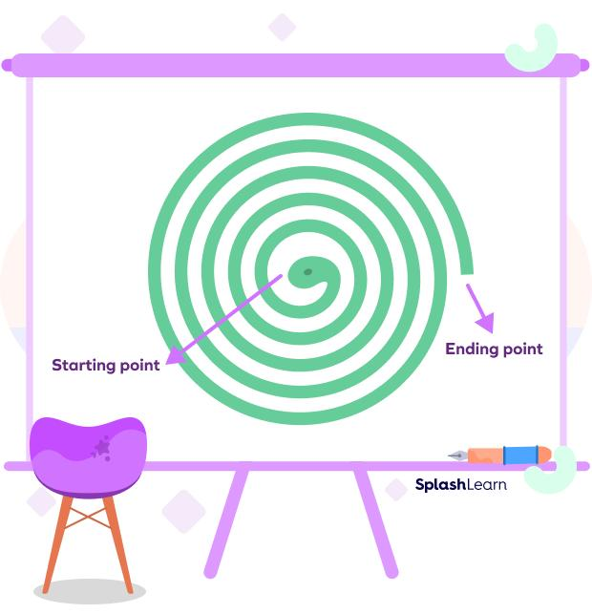
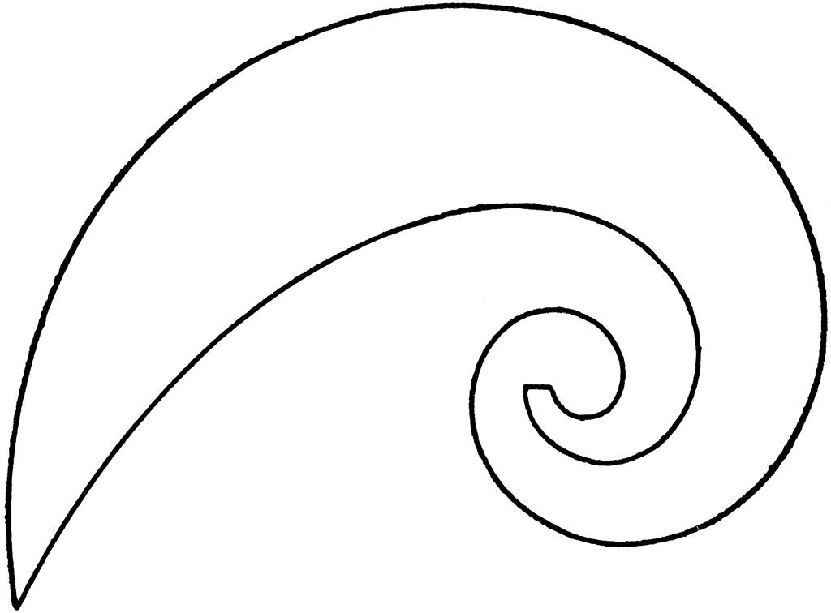

Irregular Open Curves vs. Irregular Closed Curves
# Source: AI Source: Provided by: [Data Path: Persons Table -> ID Column: 1, Name_En Column: Motasem Essam] -> From: [ChatGPT] on [7/25/2026]
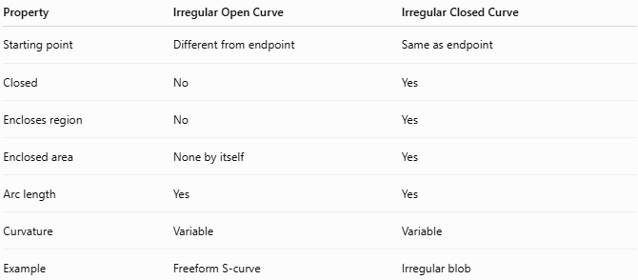
Property | Irregular Open Curve | Irregular Closed Curve
Starting point | Different from endpoint | Same as endpoint
Closed | No | Yes
Encloses region | No | Yes
Enclosed area | None by itself | Yes
Arc length | Yes | Yes
Curvature | Variable | Variable
Example | Freeform S-curve | Irregular blob

Applications
# Source: AI Source: Provided by: [Data Path: Persons Table -> ID Column: 1, Name_En Column: Motasem Essam] -> From: [ChatGPT] on [7/25/2026]
Irregular open curves are commonly used in:
- Plane Geometry
- Computer Graphics
- CAD
- Architecture
- Industrial Design
- Animation
- Typography
- UI/UX Design
- Robotics
- Path Planning
- GIS
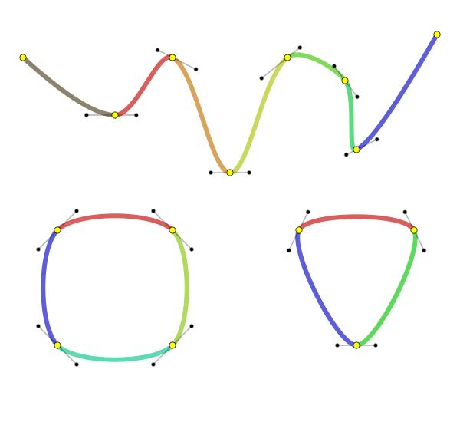
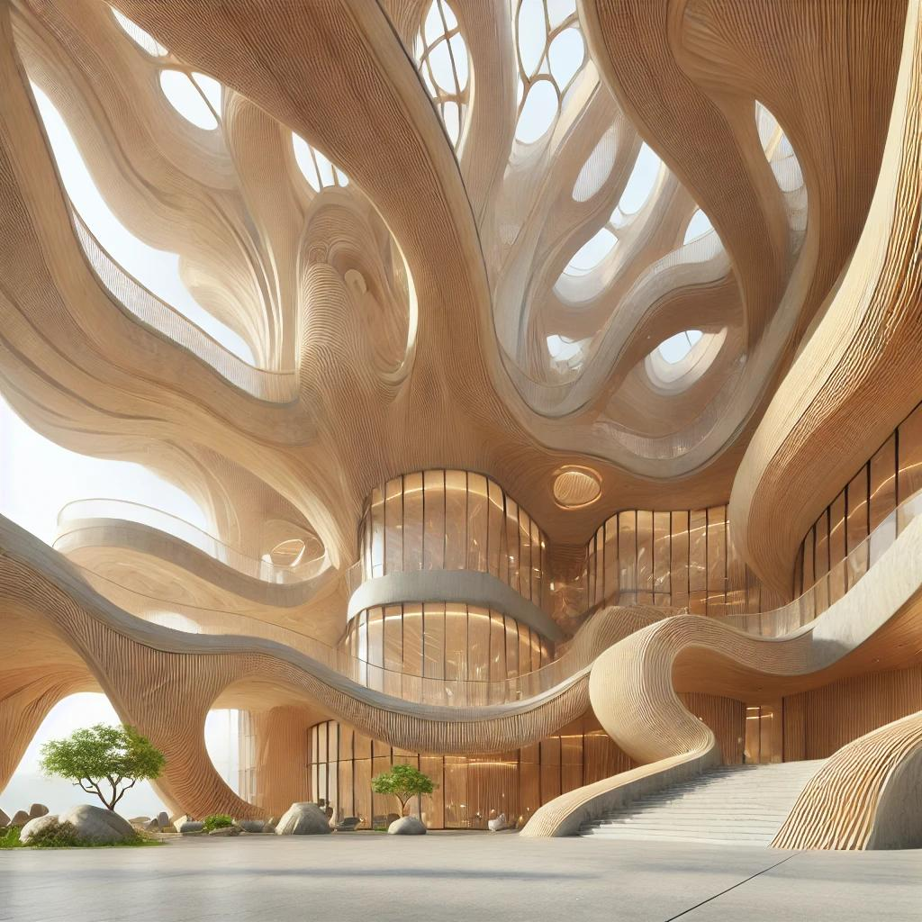
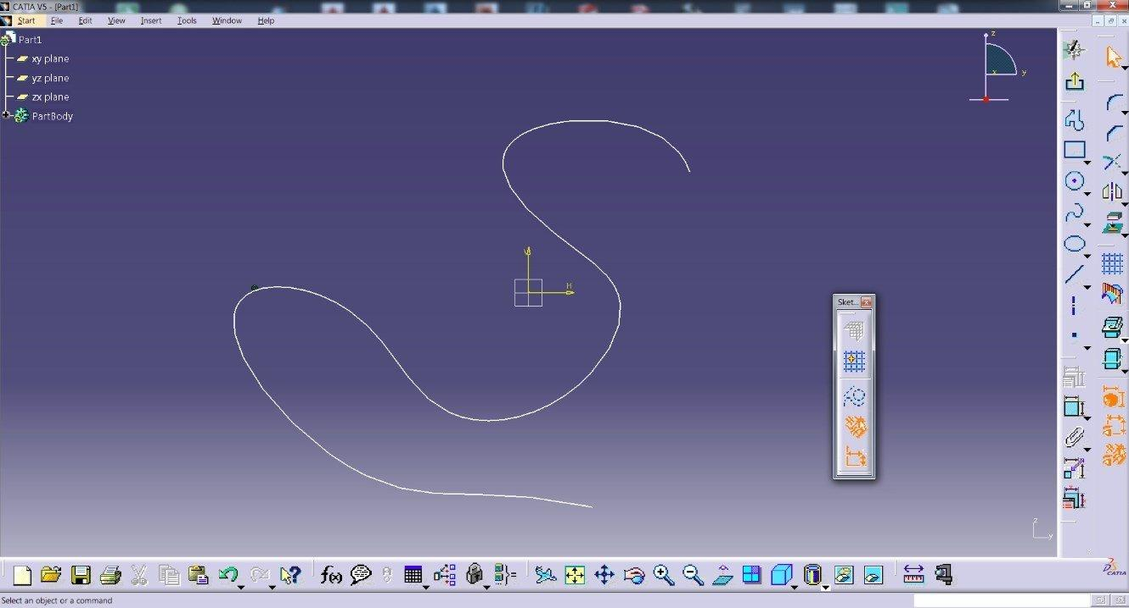
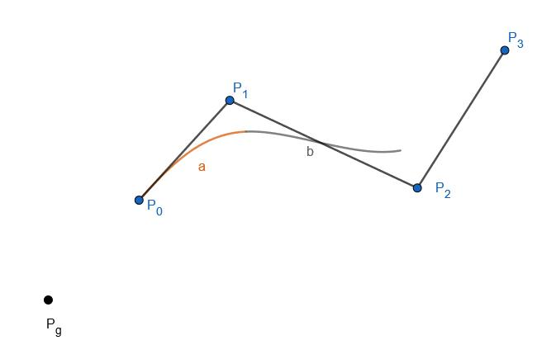
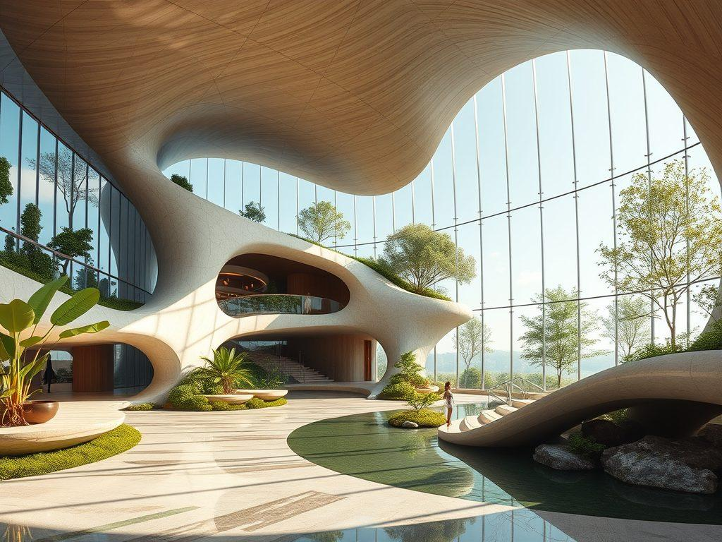

Key Points
# Source: AI Source: Provided by: [Data Path: Persons Table -> ID Column: 1, Name_En Column: Motasem Essam] -> From: [ChatGPT] on [7/25/2026]
An Irregular Open Curve:
$$\boxed{\text{Open}+\text{Curved}+\text{Irregular}}$$
It:
- Has two distinct endpoints.
- Does not close.
- Does not enclose a region by itself.
- Has variable curvature.
- Does not require a constant radius.
- Does not require symmetry.
- Can be natural, organic, freeform, wavy, or spiral-like.

Conclusion
# Source: AI Source: Provided by: [Data Path: Persons Table -> ID Column: 1, Name_En Column: Motasem Essam] -> From: [ChatGPT] on [7/25/2026]
Irregular Open Curves are continuous, non-standard curved lines whose starting and ending points are different. Unlike irregular closed curves, they do not form a closed boundary or enclose an area by themselves. Their curvature can vary freely, making them useful for representing natural paths, organic forms, freeform designs, splines, and complex boundaries in geometry, CAD, computer graphics, architecture, engineering, robotics, and GIS.

